Year 7 Science Experiment

Name ________________________

Weighting: 30%

Task 3: Experiment recount

Total: /46

**Investigating boiling water**

You will be investigating if adding other substances to water changes the time it takes for the water to boil. You will be timing how long it takes water, salt water, and water with clay to boil. You will have **four** lessons in class to plan, complete your experiment, and write up a scientific report. You will complete the experiment in small groups and the report will be written individually. The scientific report must include the following under suitable subheadings.

* Title
* Aim
* Hypothesis with scientific reasoning
* Variables (dependent, independent, controlled)
* Risk analysis
* Materials, method and diagram of the experiment will be provided by your teacher
* Table of results
* A graph of results
* Answers to discussion questions

You will also receive marks for the structure and overall presentation of your report.

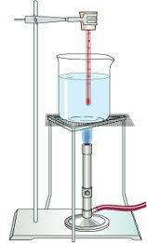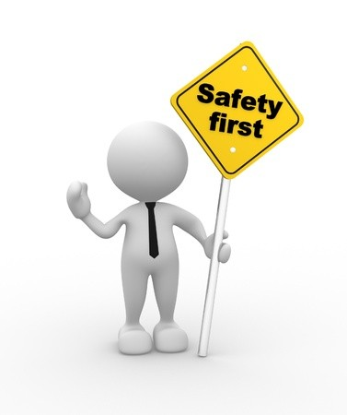

**Marking Key**

|  |  |  |
| --- | --- | --- |
| **Section** | **Criteria** | **Your mark** |
| Title | Must be accurate AND specific. | /2 |
| Aim | Outlines the purpose of the experiment starting with ‘To…’ | /2 |
| Hypothesis with scientific reasoning | Hypothesis describes the predicted outcome of the experiment mentioning both the independent and dependent variable using if…then….because….  Scientific reasoning is specific and accurate and shows evidence of research. | /6 |
| Variables | Correctly identifies independent, dependent, and **four** controlled variables. | /6 |
| Risk analysis | Identifies two specific risks and two accurate measures that could be put in place to mitigate risk. | /6 |
| Table of results | Title , Neat, Units, quantitative and qualitative observations recorded, organised | /6 |
| Graph | Type of graph correct, title, neat, units, scale, plotted correctly | /6 |
| Discussion questions | Questions answered correctly in complete sentences | /10 |
| Structure | Report has subheadings in correct order and is easy to read | /2 |
|  | **Total** | **/46** |

**Materials**

Each group will require:

* 4x safety glasses
* 1x 200ml beaker
* water
* teaspoon
* salt
* clay
* stirring rod
* stopwatch
* bunsen burner
* bench protector
* gauze mat
* tripod

**Method**

1. Safety first! Safety glasses, check uniform, clear work area.
2. Put 100ml of water in the beaker.
3. Set up your equipment like in the diagram below using the beaker with just water.
4. When it is safe to do so, light your Bunsen burner. Turn it to the blue flame and start your stopwatch.
5. Stop your stopwatch when the water begins to boil. Record the results in your table.
6. Safely turn off the bunsen burner.
7. Repeat steps 3-6 with water and 2 teaspoons of salt.
8. Repeat steps 3-6 with water and 2 teaspoons of clay powder.
9. Pack away your equipment safely.

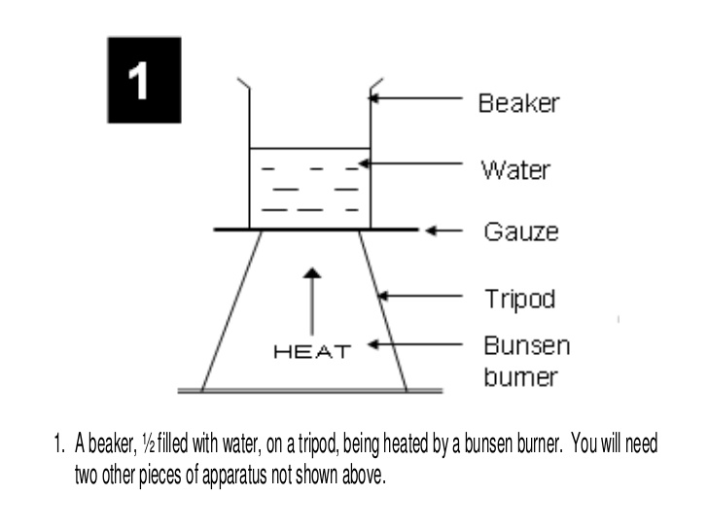

**Discussion**

1. Consider when you stopped your timer during the experiment

A) How did your group decide when to stop the timer? Describe your observations. (1 mark)

_______________________________________________________________________________________

_______________________________________________________________________________________

B) If you were to repeat this experiment what could you do to make the above measurement more accurate? (2 marks)

______________________________________________________________________________________

______________________________________________________________________________________

______________________________________________________________________________________

2. Which type of substance took the longest to boil? (1 mark)

______________________________________________________________________________________

3. Did the results of this experiment support your hypothesis? (Circle one) (1 mark)

Support Not support

4 . Why do you think the substances did not all start boiling at the same time? (2 marks)

______________________________________________________________________________________

______________________________________________________________________________________

______________________________________________________________________________________

**Reflection**

1.What did you find most challenging about this experiment? (1 mark)

______________________________________________________________________________________

______________________________________________________________________________________

2. What could you do to overcome this challenge next time? (2 marks)

______________________________________________________________________________________

___________________________________________________________________________________________________________________________________________________________________________